- In people tab, under staff when you add a driver it does not show at the Drivers page in the Delivery tab. So we think the Drivers page is not that important because we have the Staff page where we can add a driver.
Suggested Fix:
- Merge Drivers into the Staff page: Since drivers are already being added and managed under People > Water Staff, the separate Drivers page under Delivery is redundant. Remove the standalone Drivers page entirely and rely on the Staff page as the single source of truth for all personnel including drivers.
- If the Drivers page must stay, sync it automatically: If the Drivers page is kept for delivery-specific data (like license and assigned vehicle), then any staff member added with the role "Driver" should automatically appear there. There should never be two separate places where you manually add the same person — that creates duplicate data and confusion.
- Add driver-specific fields to the Staff form: Fields currently unique to the Drivers page (License number, Assigned vehicle) can simply be added as optional fields on the Staff creation form, visible only when the selected role is "Driver." This way one form captures everything.

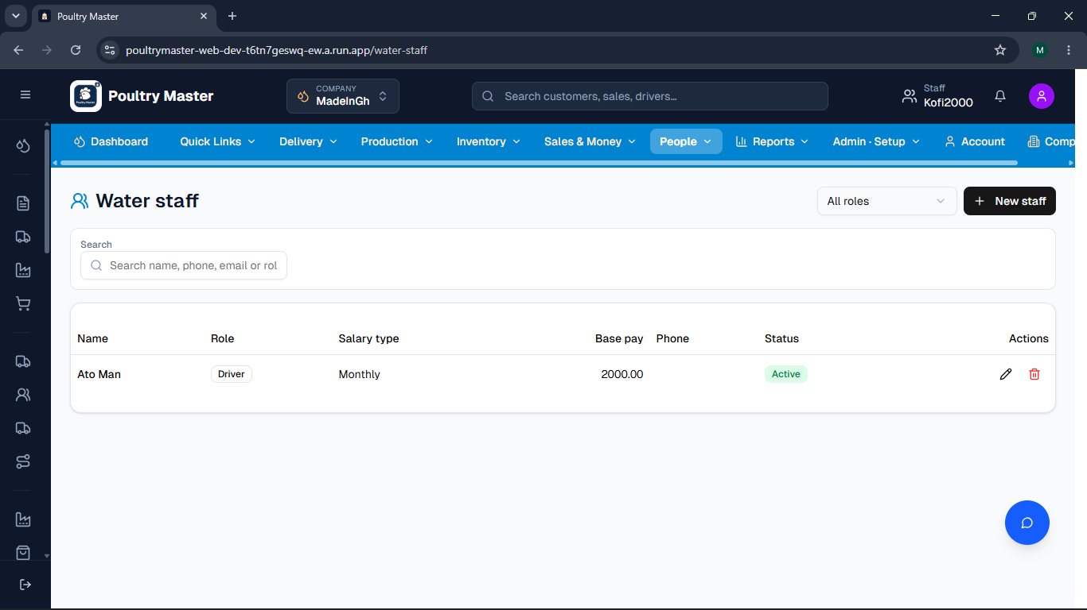

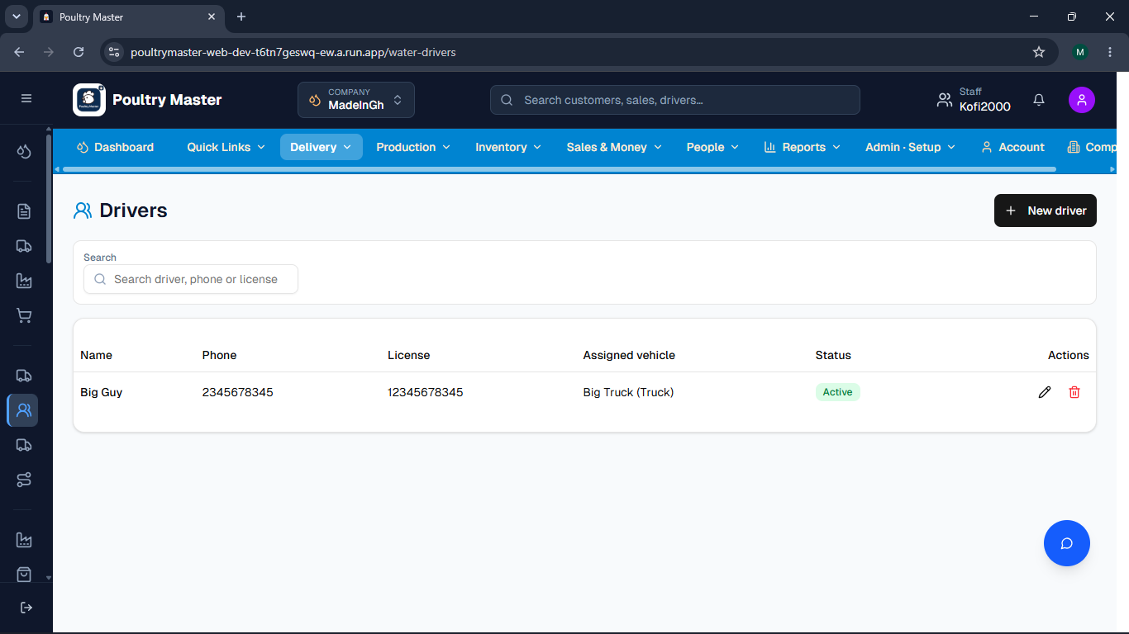

2 In the companies tab, it shows that we have no company, but we do have a company. Then we created a poultry farm, which resulted in the deletion of the water company we had.

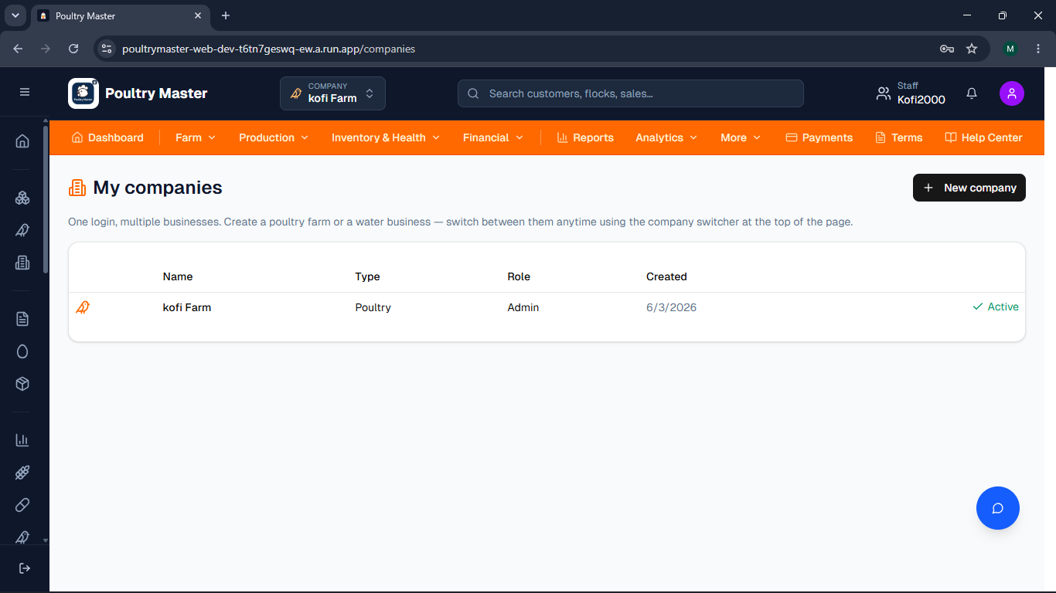
3 The chat icon is covering the delete icon.
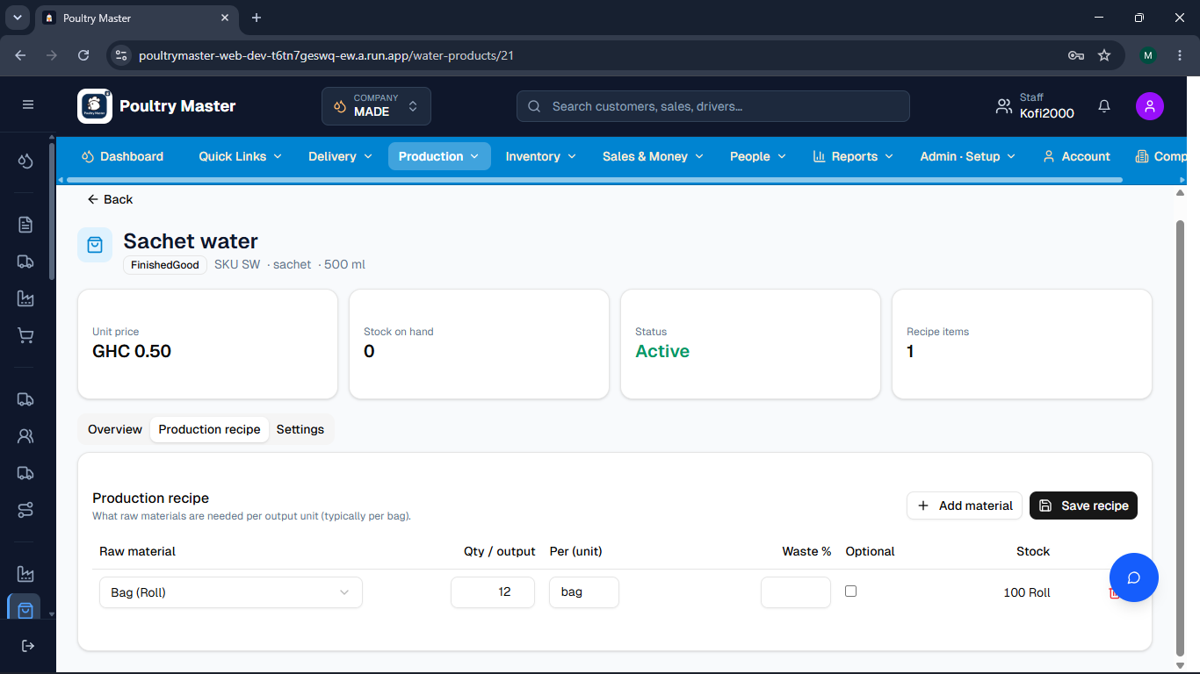
4 The Money Collected section should use a dropdown for payment methods. For example, if "Cash" is selected, a textbox will appear. This change will simplify the Money Collected section.
Suggested Fixes:
- Replace the static fields with a single "Payment method" dropdown — Instead of showing Cash, MoMo, Bank, and Credit sales all at once, show a single dropdown first: "How was payment made?" with options like Cash, Mobile Money (MoMo), Bank transfer, and Credit sale. Only the selected method's input field then appears below it.
- Show/hide fields based on selection — For example:
  - If "Cash" is selected → show one text field labeled "Amount collected"
  - If "Mobile Money" is selected → show the MoMo provider dropdown + amount field
  - If "Bank" is selected → show a bank/cheque amount field
  - If "Credit sale" is selected → show a note field (e.g. customer name or reference)
- Allow multiple payment methods when needed — For split payments (e.g. part cash, part MoMo), add a small "+ Add payment method" link that lets the user add a second method. This keeps the form clean by default while still supporting edge cases.
- Show a running total as methods are added — Display a small summary like "Total collected: GHC 5,600.00" that updates as the user fills in amounts, so they can confirm it matches the Expected cash before submitting.
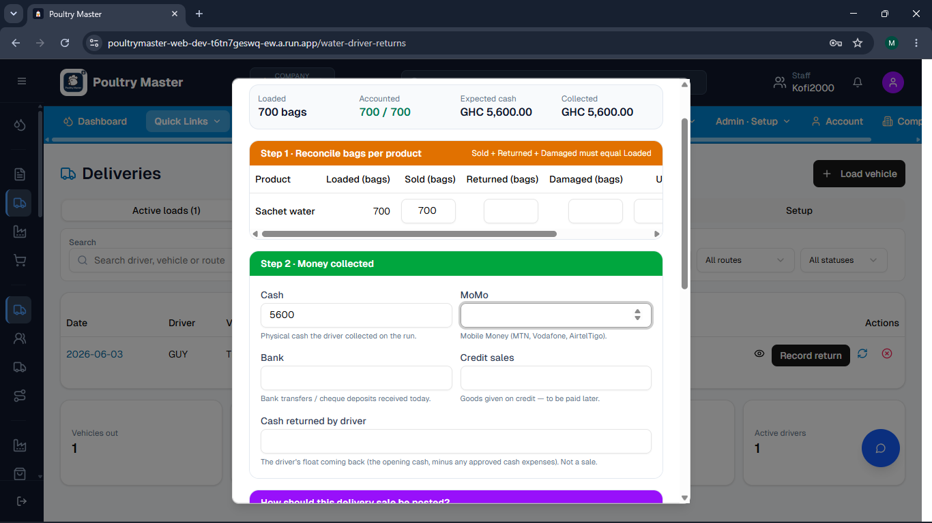
5 In the sales and money tab, under the new water sale section, the text boxes are overlapping with the text because they are too small.
Suggested Fixes:
- Increase column widths for the items table — The Product, Selling Unit, Quantity, Unit Price, and Line Total columns are too narrow. Each column should be wide enough to display its content without clipping. At minimum, the Product column needs more space since product names are long (e.g. "Sachet water (sachet) · stock 300").
- Truncate with a tooltip instead of cutting off — If screen space is limited, truncate long product names with an ellipsis (...) but show the full name on hover, so staff can always see what they selected.
- Stack the modal wider — The modal dialog itself can be made wider (e.g. from ~480px to 600px) to give the items table enough room to breathe without needing to shrink any column.
- Use two lines for the product cell — Show the product name on the first line and the stock info (e.g. "stock 300") as a smaller muted line below it, instead of cramming both into one line in a narrow cell. This reduces horizontal pressure on the whole row.
- Right-align numeric columns — Quantity, Unit Price, and Line Total should be right-aligned. This is a standard table convention and makes numbers easier to read and less likely to visually collide with adjacent text.

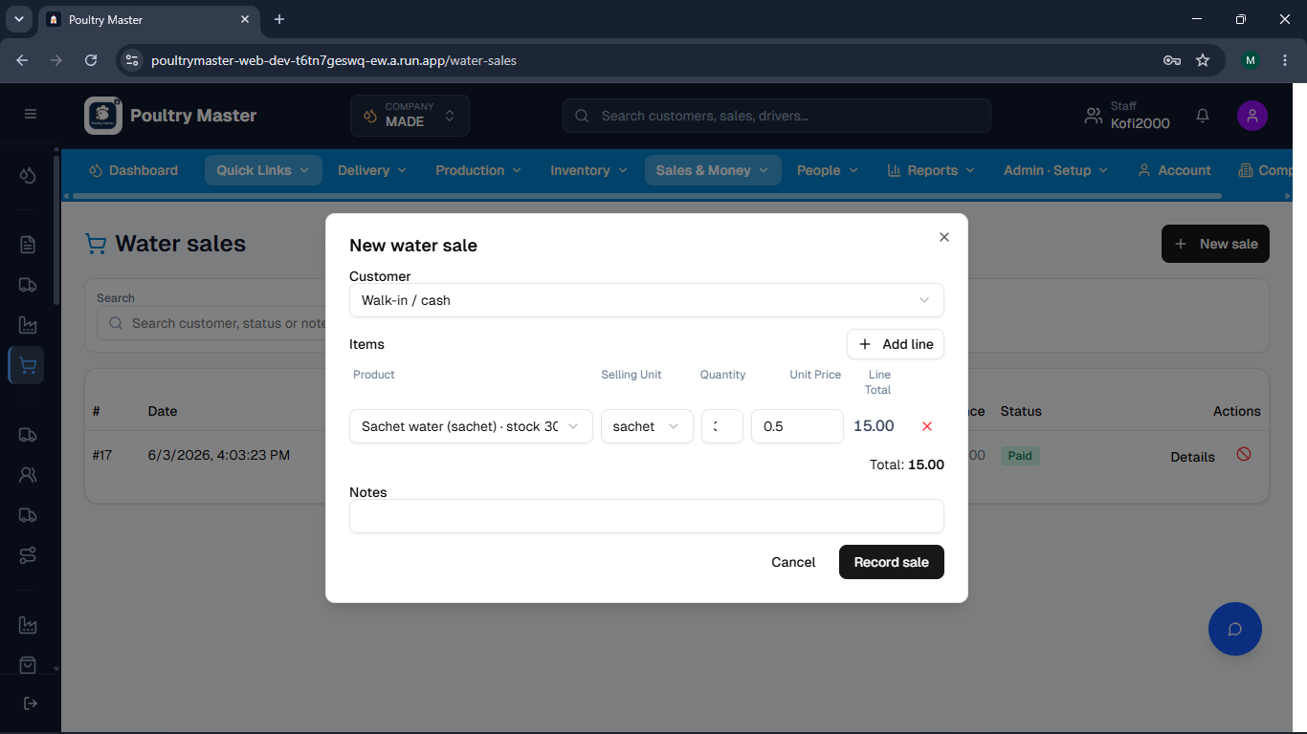

6. The water sales system is not user-friendly. When you record a sale, it is marked as pending. It only changes to paid if you click on the "Details" button and then select "Record Payment." Users may not understand the purpose of the "Details" button, which can lead to confusion.
Suggested Fixes:
1. Add a payment option at the point of sale Right in the "New water sale" modal, add a simple toggle or radio:
Payment status: ⚪ Pay later (pending) 🔵 Paid now (cash)
This lets walk-in cash sales be recorded as paid immediately, which is the common case.
2. Rename or replace "Details" with a clearer action Instead of a vague "Details" button next to pending sales, show a prominent "Mark as Paid" or "Collect Payment" button directly in the table row — so staff can act without needing to know what "Details" means.
3. Visual urgency on pending rows The balance column already shows red for unpaid amounts, which is good. But you could add a small inline prompt like "Awaiting payment →" as a clickable label on pending rows.
4. Confirm-before-close When a sale is recorded as pending, show a brief toast/alert: "Sale #20 recorded. Tap to collect payment now." — giving staff an immediate path forward.

